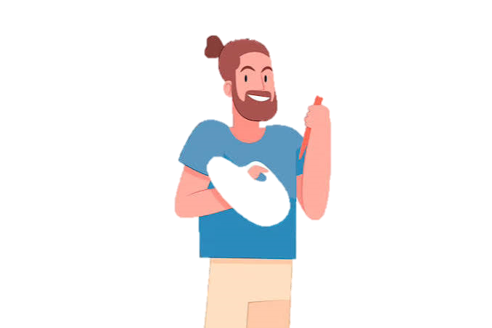
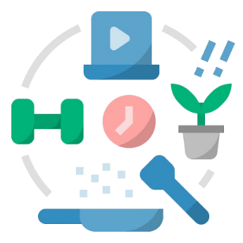
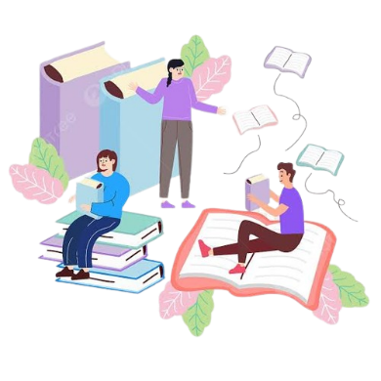

MY FAVORITE HABITS

- Coding & AI Development: I love building applications using code and artificial intelligence, moving on from basic block coding platforms like Scratch to advanced tools.
- Creative Pranking: I enjoy brainstorming and executing harmless, funny pranks to bring humor to my family and friends.
- Experimental Science: I like acting like a mad scientist, mixing different liquids together to see what chemical reactions and dramatic mini-explosions I can create.
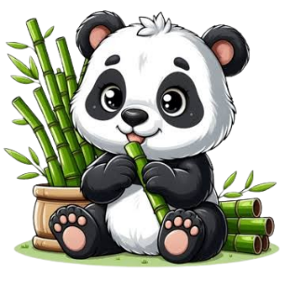
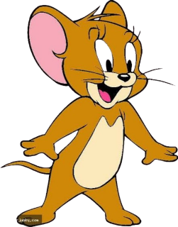

My favorite habits

